System Design Schematics

**SMART System Design**

**STRETCH System Design**

**Note:** The SMART system design and Stretch system design objectives can be referenced in the 'Docker MITgcm_ECCO_Project_Overview.docx' document.

**Product System Designs**

1) Consider developing flowcharts that communicate flow of information in product systems to include 'systems' like Containerization System, Containerization Engine, host machine hardware, software

2) Perhaps, the subsystems could involve the individual containers themselves and the behavior of their associated source code.

**Project Workflow Design**

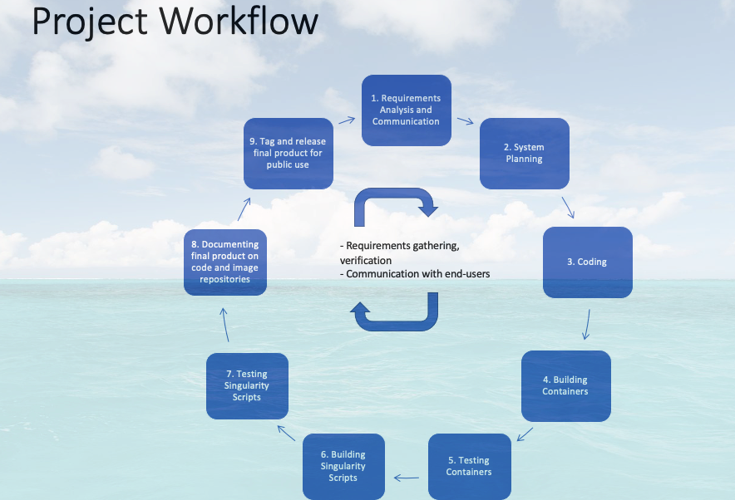

**Project Communication Hierarchy**

